**WMEC111 Unity Assignment**

**Marks Claimed:**

* Indoor Section made using Probuilder and Unity Primitives (25%)
* Outdoor Section made using the Terrain Editor, including textures, trees and grass (25%)
* Textures on the Indoor Section (5%)
* A Simple single-state animation (5%)
  + A complex animation that responds to a mouse event (5%)
* Direct light sources beyond the default directional light (5%)
* Appropriately applied effects via a post-processing stack (5%)
* Use of Multiple Cameras (10%)
* Particle Effects (10%)
* Use of NavMesh Agents (5%)

Total Marks Claimed: 100%

**The Hut**

The hut has textures on the walls, door and ceiling. The monitors in the Hut uses a post processing stack and rendering to a texture through a second camera. The door uses a complex animation that responds to a mouse click to open and close. The fire within is a Direct light source and a particle effect. The table is made using Unity Primitives and imported Google Image.

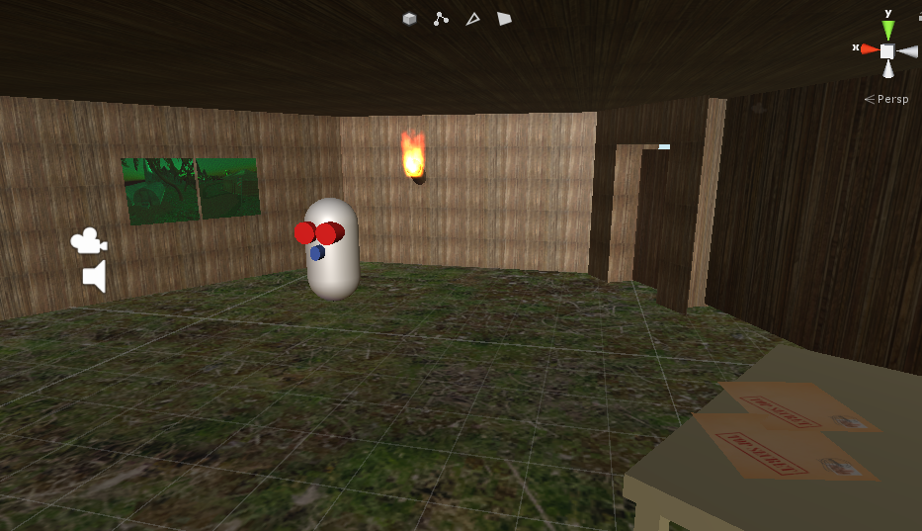

**Terrain**

I used a sandy terrain with grass and palm trees. There is a mountain within two corners of the terrain. The directional light is placed for a sunset setting.

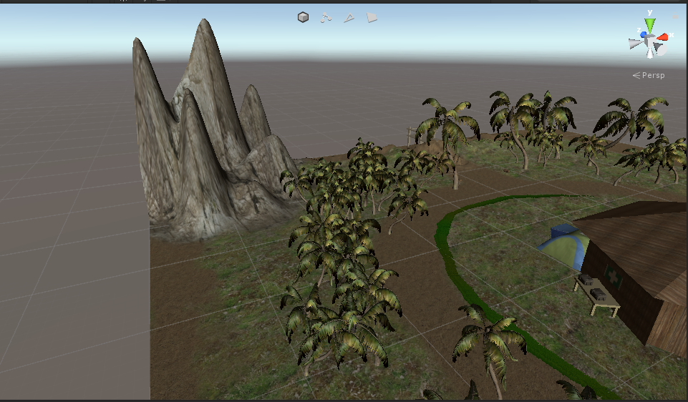

**The Dock**

The dock was made using Unity Primitives. It has an imported texture.

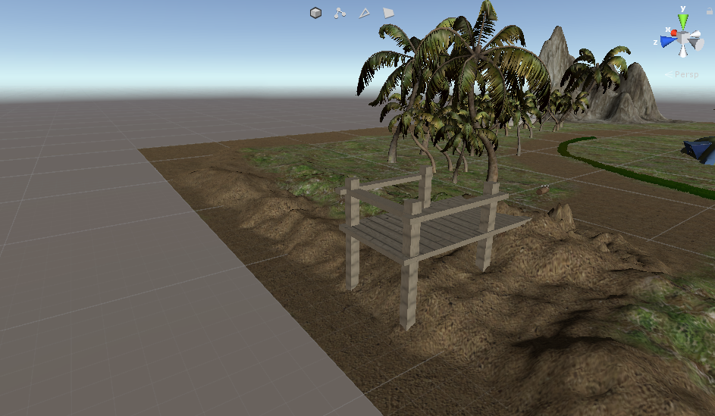

**The Flag**

The Flags were made using Unity Primitives and have imported Textures.

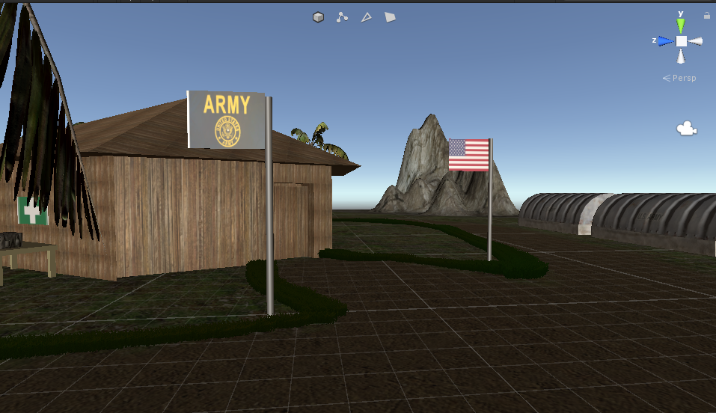

**The Robot**

The Robot was made using Unity Primitives. I used a NavMesh Agent for the robot to patrol within the Hut.

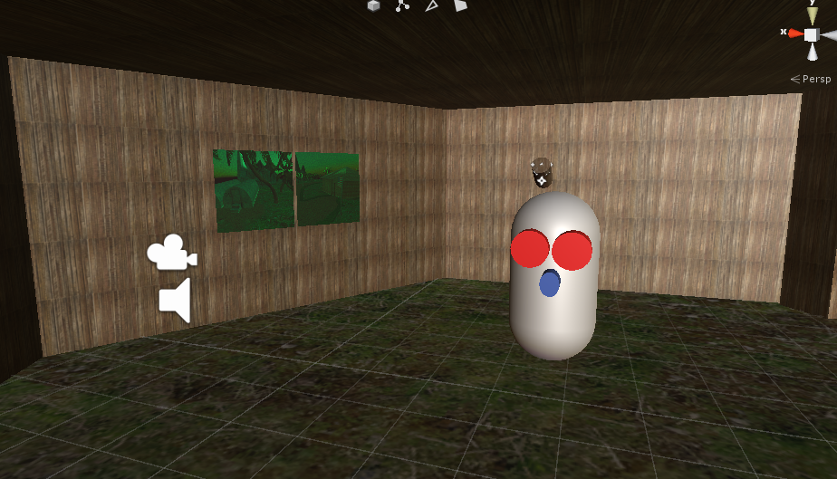

**Challenges & Changes**

I found it difficult to manage the terrain heights due to their sensitive reactions. I wanted to add more within my hut including more cameras. After my GDD feedback I decided to base the design less off of North Sentinel Island and more off a fictional world.

**Assets Used:**

* Tents by Vis Games
* Army Bunker by Duane’s Mind
* First Aid Army Kit by LemmoLab